**Mankato to Mapleton**

* Take State Highway 22 about 4 miles from Mankato south towards Mapleton.
* At County Road 16 turn left (east) -Hwy 22 will be blocked here.
* County Road 16 will go around some curves.
* Turn right (west) on County Road 10 at the stop sign.
* County Road 10 will curve to the right.
* About ½ mile after the curve, turn left (south) on County Road 16.
* At the “T” intersection turn left (east) on County Road 4.
* About ¼ mile later turn right on County Road 52.
* County Road 52 will curve to the right and become County Road 21, this will take you into Mapleton.
* At the stop sign on County Road 21, proceed straight (west) into town to the Library City Park.

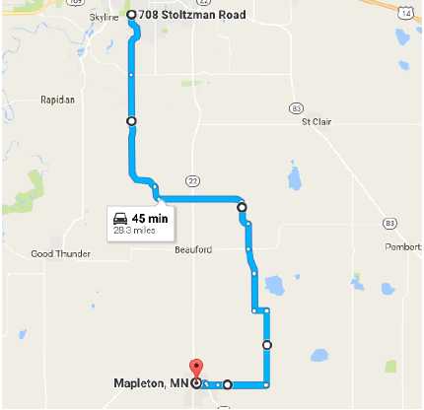

**OR**

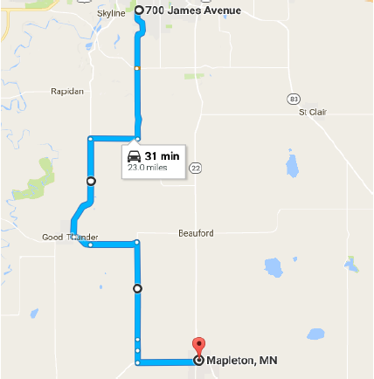

* Take County Road 1 (old State Highway 66) towards Good Thunder.
* At the intersection of County Road 1 and County Road 10, turn left (east).
* County Road 10 will curve outside of Good Thunder and then again before County Road 39.
* At County Road 39, turn right (south) until you reach State Highway 30.
* At State Highway 30 turn to the left (west).
* You should proceed into town until you see signs at the Library City Park.