**Mankato to Mapleton**

* Take State Highway 83 (south side of Mankato) about 13 miles from Mankato south east towards Pemberton.
* At County Road 10 turn right (west).
* Take County Road 10 back to the West about 9 miles.
* You will come to a stop sign at the intersection of County Road 10 and State Hwy 22. .
* Turn left (south) on State Hwy 22 at the stop sign.
* Take State Hwy 22 South for about 5 miles.
* Proceed into town to the Library City Park.

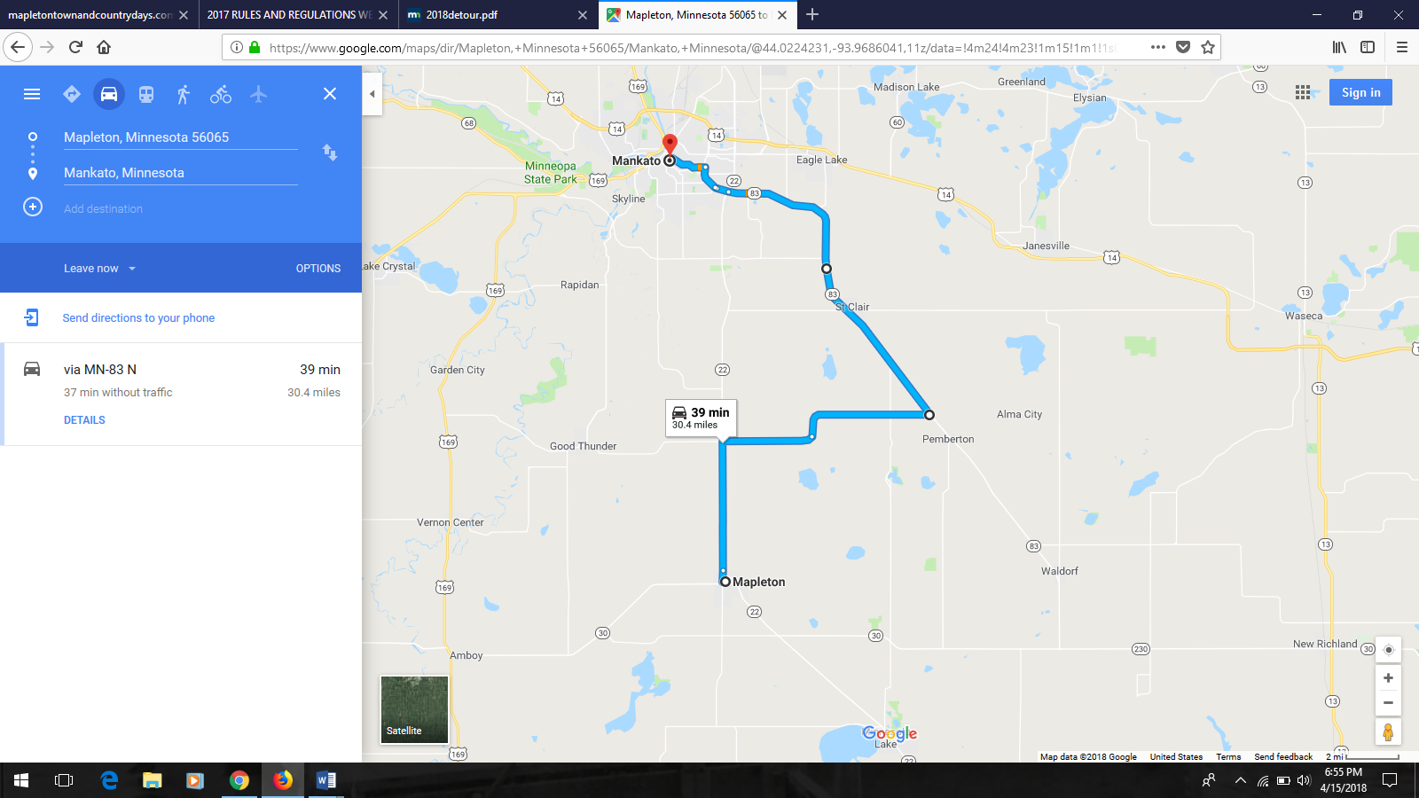

**OR**

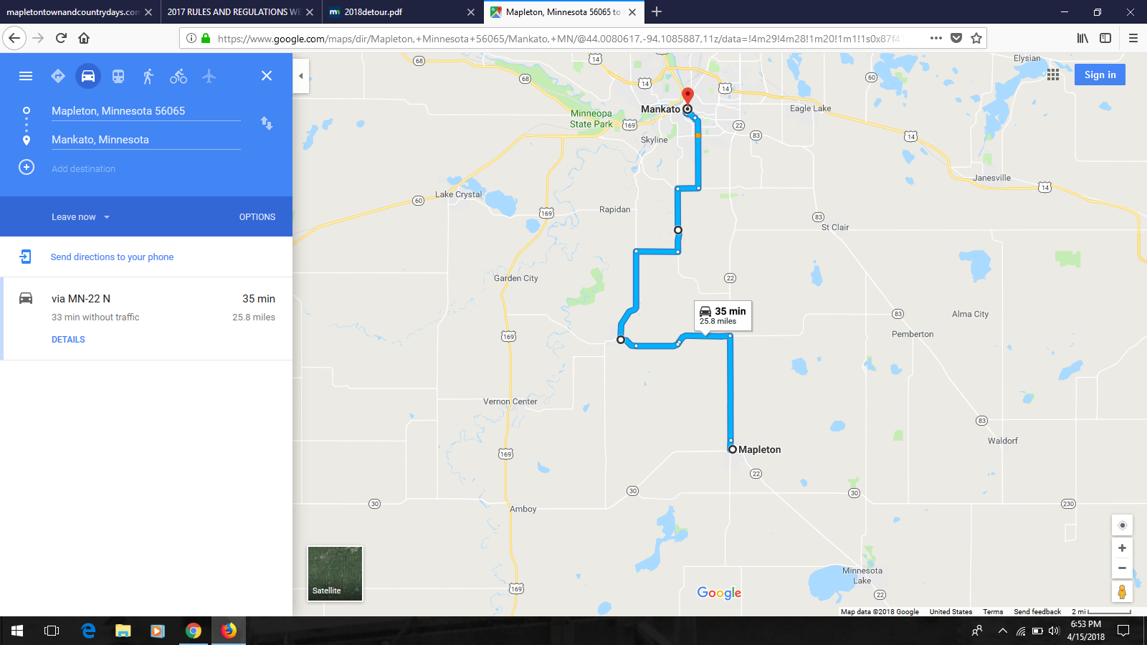

* Proceed South of Mankato on State Hwy 22.
* When you reach the corner of County Road 90, turn right (west).
* Proceed down county road 90 for about 1 mile.
* Turn right (south) on County Road 16.
* Proceed down County Road 16 for about 3 miles.
* Take a right (west) on County Road 35 for about 3 miles.
* At the stop sign take a left (south) onto County Road 1 (old hwy 66).
* Take County Road 1 into Good Thunder about 5 miles.
* At the intersection of County Road 1 and County Road 10, turn left (east) about 6 miles.
* Continue on until you reach the stop sign at County Road 10 and State Hwy 22.
* Turn right (south) on State Hwy 22 at the stop sign.
* Take State Hwy 22 South for about 5 miles.
* Proceed into town to the Library City Park.